Software Requirements Specification

For Major Project

“EMERGENCY ALARM”



|  |  |
| --- | --- |
| Prepared by:  Prachi Gupta(PCE15IT032)  Shaily Rani(PCE15IT049)  S. Rajshree(PCE15IT047) | Guide:  Shirish Nagar  Assistant Professor |
| Department of Information Technology,  Poornima College of Engineering  18 August 2018 Session – 2018-19 | |
|  | |

Table of Contents

|  |  |
| --- | --- |
| Table of Contents | Page No. |
| 1. Introduction |  |
| 1.1 Purpose | 2 |
| 1.2 Feasibility | 2 |
| 2. Functional /Nonfunctional Requirements |  |
| 2.1 Functional Requirement | 3 |
| 2.2 Nonfunctional Requirements | 4 |
| 3. System Features |  |
| 3.1 Module 1 | 5 |
| 3.1 Module 2 | 5 |
| 3.1 Module 3 | 6 |
| 3.1 Module 4 | 6 |
| 4. Analysis Diagrams | 7-10 |
| 4.1 Use Case Diagram  4.2 Sequence Diagram  4.3 Component diagram  4.4 Data Flow Diagram(Optional)  4.5 ER Diagram  4.6 Activity Diagram  4.7 Project Schedule Diagram |  |
| 5. Other Requirements | 10 |
| 6. Glossary | 10 |
| 7. Appendices | 11 |
| 8. References | 11 |
| 9. Guide’s Comments | 11 |

Revision History

|  |  |  |  |
| --- | --- | --- | --- |
| **Name** | **Date** | **Reason For Changes** | **Version** |
|  |  |  |  |
|  |  |  |  |
|  |  |  |  |
|  |  |  |  |

# Highlights of Overall Modification

|  |  |  |  |
| --- | --- | --- | --- |
| **SNO.** | **ADDED** | **SNO.** | **REMOVED** |
| 1 | Web application for hospitals which will show whether they have accepted our emergency request for ambulance or not. |  |  |

# Introduction

## Purpose

Emergency alarm is an android application generally designed for overcoming the problems caused due to unavailability of ambulance at the time of accidents. This application helps us in a way that whenever any accident occurs, we just need to connect to our application and it will send notification to hospitals in a range of 1-3 km and hospital will appoint ambulance on the basis of First Come First Serve with one backup. The hospital will also get the details of the victim like his/her name, blood group, address (if available). According to the details provided by the victim side, the ambulance sent by the hospital will have those basic hospitality facilities necessary for that victim. The application will work in such a way that if any accident occurs, the person who is attending that victim will connect to this application by turning his/her GPS location ON. Then the GPS will search the hospitals in a range of 1-3kms.

**1.2 Feasibility**

* This will provide faster service of ambulance.
* Early medical hospitality providence.
* Reduction of number of accidents through the preventive measures taken by the municipality corporation on the basis of weekly report generated by this application.

**2. Functional /Nonfunctional Requirements**

**2.1 Functional Requirements**

* A system for helping victim by making an emergency call.
* One can just tap on the button provided in the app to make emergency call.
* The facility to see nearest hospital.
* Hospital is selected on the basis of FCFS.
* The facility with one backup ambulance.
* Details of driver and its location is shared by the hospital.
* Daily report of accidents is sent to Municipal Corporation
* Web application which will show the confirmation of emergency request by the hospital

## 2.2 Nonfunctional Requirements

## Performance Requirements

The system is expected to response in a short time. There is also a backup facility of ambulance. Moreover, nearest hospitals are given first priority.

## Safety Requirements

Details shared by the attendant of that victim will be kept secret and will be secured so that no misuse takes place.

## Security Requirements

1. Secure access of data of patient.

2. 24x7 availability.

3. Flexible service based architecture will be highly desirable for future extension.

## Software Quality Attributes

## ****Usability**:** The application is developed with a user friendly environment such as the font size, text alignment and other complicated things are adjusted in a simple way. User can easily understand the functions of the application.

##### **Reliability:** System will be able to perform operation efficiently with a reliable environment and with minimum chances of losing data.

##### **Supportability:** This application can be easily downloaded from Google play store and can be used rapidly in case of emergency.

## 2.3 Technical Requirments ( Hardware /Software)

## Operating Environment

Our application will require android operating system and the details will be stored in the database naming Firebase Database. All this runs effectively with Internet connectivity as it is an Android application and it will use GPS facility to trace both the ambulance and victim’s position.

## Hardware Interfaces

* GPS is required for tracking the location of victim and driver.
* 24*7 Internet connectivity
* Laptop for hospital side web application.

## Software Interfaces

* Languages Used to implement : JAVA, Html, CSS
* Operating System: Android, Windows
* Internet Browser: Mozilla/Google chrome
* Front End: Xml, Html, CSS
* Back End: Java, PHP
* Database: Firebase, MySQL
* Tool: Android studio, Notepad++

## Communications Interfaces

* The application will contain a form which will be filled by the attendant of the victim. This form will contain the basic information of the victim like his/her name, address, phone number and blood group.
* A textbox will be displayed which will contain the information of the ambulance and it’s driver and it will be shared by the hospital to our application.

# System Features

## Module 1: User

* + 1. **Description and Priority**

User can be anyone, it may be the attendant of the victim or it may be victim itself.

It is of Medium priority as the user will be the main asset of this application. This application is beneficial for them as they won’t be waiting for a long time for ambulance when they entertain any victim.

* + 1. **Stimulus/Response Sequences**

User will be able to make an emergency call to various hospitals using this application. Also with the help of this application he will be able to trace the location of the ambulance along with the details of the driver.

## Module 2: Application

* + 1. **Description and Priority**

Application is the main key connecting users with the hospitals at ease. It is of the highest priority as everything is happening with it’s help only.

* + 1. **Stimulus/Response Sequences**

Application will search all the nearby hospitals which will be in the range of 1-3kms from the victim’s location and will send the notification to them. It will receive the information of the driver and the ambulance number. That ambulance could be tracked using the GPS by the user. Also at the end of each week, it will generate a report which will contain the information regarding the number of accidents which took place during that week and at what-what places accidents took place.

## Module 3: Hospital

* + 1. **Description and Priority**

Hospitals will be the second last step of all the process. They will provide the hostage and treatment to the victims.

* + 1. **Stimulus/Response Sequences**

Hospital which will be the nearest to the victim’s location will accept the request and will quickly share the details of the ambulance and it’s driver with the application, and will send the ambulance which will contain the basic hospitality materials required for the victim.

## Module 4: Municipality Corporation

* + 1. **Description and Priority**

Municipality Corporation will be the last factor of this project. It has the least priority amongst all.

* + 1. **Stimulus/Response Sequences**

On the basis of the weekly report generated by the application the municipality corporation will go through the places at which maximum number of accidents took place. And will take some preventive measures to overcome all the causes of accidents at those places. This will result in the reduction of the accidents and many lives will be saved.

# Analysis Diagrams

* **Use Case Diagram**

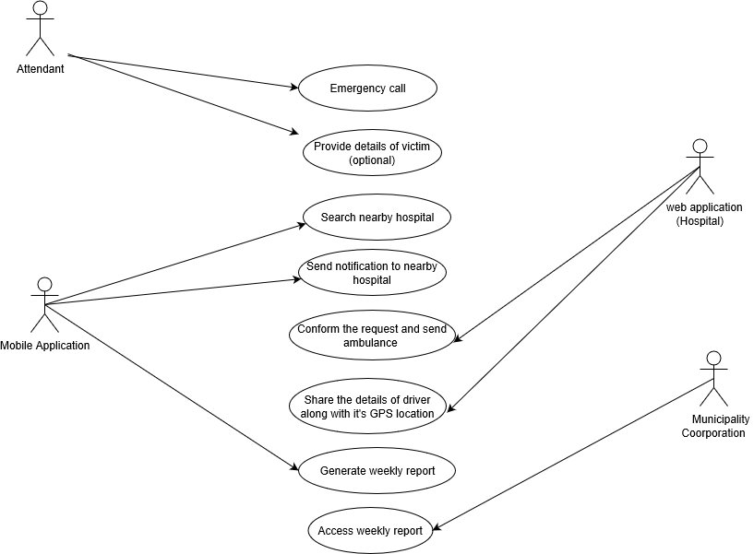

* **Sequence Diagram**

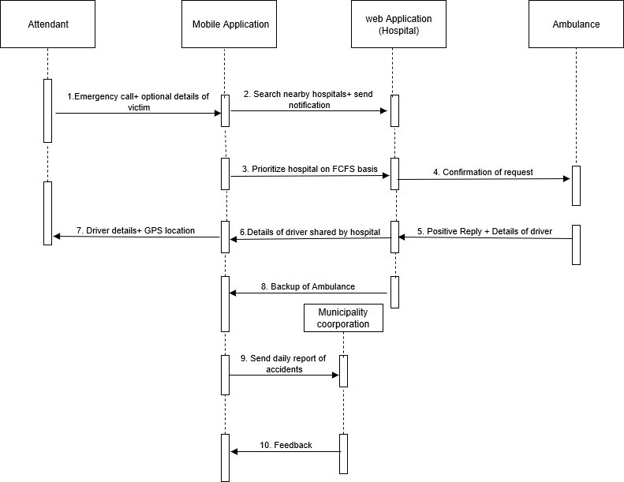

* **Component diagram**

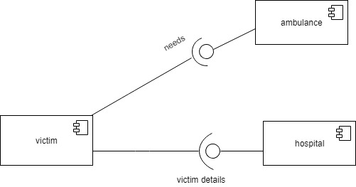

* **ER Diagram**

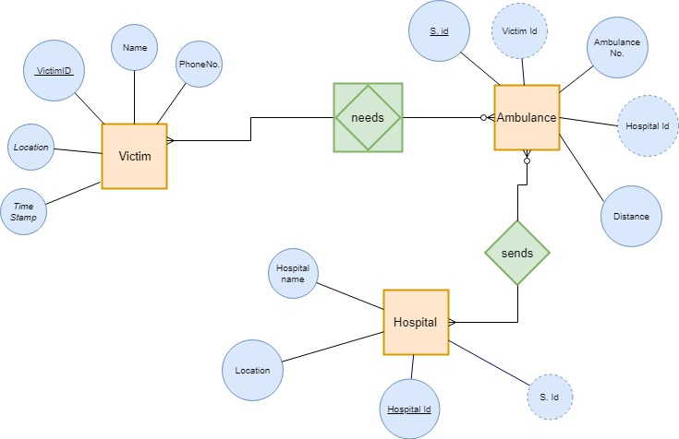

* **Activity Diagram**

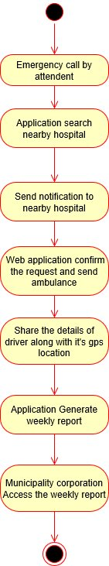

# Other Requirements

* Sending of weekly report to Municipality Corporation
* Details of victim/patients if known
* Details of driver and its location

# Glossary

* GPS: Global Positioning System
* FCFS: First Come First Server

# Appendices

* **ER Diagram**

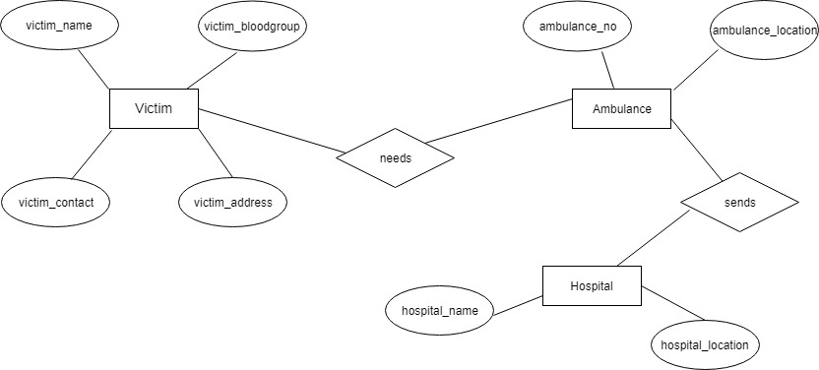

# References

* <https://bohatala.com/ambulance-management-system/>
* Existing project i.e. “Call Emergency App”

# Guide’s Comments